# JS Front-end: Exam Preparation 2

**Link to contest**: <https://alpha.judge.softuni.org/contests/js-front-end-retake-exam-19-april-2024/4540>

## 01.Spellbook Unraveling

**Environment Specifics**

Please be aware that every JS environment may **behave differently** when executing code. Certain things that work in the browser are not supported in **Node.js**, which is the environment used by **Judge**.

The following actions are **NOT** supported:

* **.forEach()** with **NodeList** (returned by **querySelector()** and **querySelectorAll()**)
* **.forEach()** with **HTMLCollection** (returned by **getElementsByClassName()** and **element.children**)
* Using the **spread-operator** (**...**) to convert a **NodeList** into an array
* **append()** in Judge (use only **appendChild()**)
* **prepend()**
* **replaceWith()**
* **replaceAll()**
* **closest()**
* **replaceChildren()**
* Always turn the collection into a **JS array** (forEach, forOf, et.)

If you want to perform these operations, you may use **Array.from()** to first convert the collection into an array.

*You find yourself in a dimly lit chamber filled with ancient tomes and mystical artifacts. The air crackles with arcane energy as you embark on a journey to decipher the secrets hidden within the pages of a spellbook. Each incantation holds the potential to unleash powerful magic or unveil hidden truths.*

Write a program that performs a series of commands in order to decode that information. First, you will receive a **string** representing a mysterious spell waiting to be unraveled, and afterwards, until the command "**End**" is given, you will be receiving strings with commands **split** by a **exclamation mark**. The **commands** will be the following:

### **"RemoveEven"**

* + The encoded spell is changed to consist only of its characters at **even** **indices.** Then, the updated spell is **printed**.

### **"TakePart!{from index}!{to index}":**

* + Selects a portion of the spell specified by two numbers, unveiling a segment of its hidden power and then **prints** the spell.

### **"Reverse!{substring}":**

* + If the spell contains the given **substring**, **cut it out**, **reverse** it and **add** it at the **end** of the spell. Then, **print** the updated spell.
  + Otherwise, print "Error".
  + This operation should replace only the first occurrence of the given **substring** **if there are two or more occurrences**.

### Input

* You will be receiving strings until the "**End**" command is given.

### Output

* After the "End" command is received, **print**:
  + "The concealed spell is: {spell}"

### Constraints

* All given **commands** will be **valid**.
* **Aways** will recive encoded spell

### Examples

|  |  |
| --- | --- |
| **Input** | **Output** |
| (["asAsl2adkda2mdaczsa",  "RemoveEven",  "TakePart!1!9",  "Reverse!maz",  "End"]) | aAlakamaza  Alakamaz  Alakazam  The concealed spell is: Alakazam |
| **Input** | **Output** |
| (["hZwemtroiui5tfone1haGnanbvcaploL2u2a2n2i2m",  "TakePart!31!42",  "RemoveEven",  "Reverse!anim",  "Reverse!sad",  "End"]) | L2u2a2n2i2m  Luanim  Lumina  Error  The concealed spell is: Lumina |

## 02. Adopt Me

**Environment Specifics**

Please be aware that every JS environment may **behave differently** when executing code. Certain things that work in the browser are not supported in **Node.js**, which is the environment used by **Judge**.

The following actions are **NOT** supported:

* **.forEach()** with **NodeList** (returned by **querySelector()** and **querySelectorAll()**)
* **.forEach()** with **HTMLCollection** (returned by **getElementsByClassName()** and **element.children**)
* using the **spread-operator** (**...**) to convert a **NodeList** into an array
* **append()** (use only **appendChild()**)
* **prepend()**
* **replaceWith()**
* **replaceAll()**
* **closest()**
* **replaceChildren()**

If you want to perform these operations, you may use **Array.from()** to first convert the collection into an array.

**Use the provided skeleton to solve this problem.**

**Note**: You **can't** and you have no permission to **change** directly the given HTML code (index.html file).

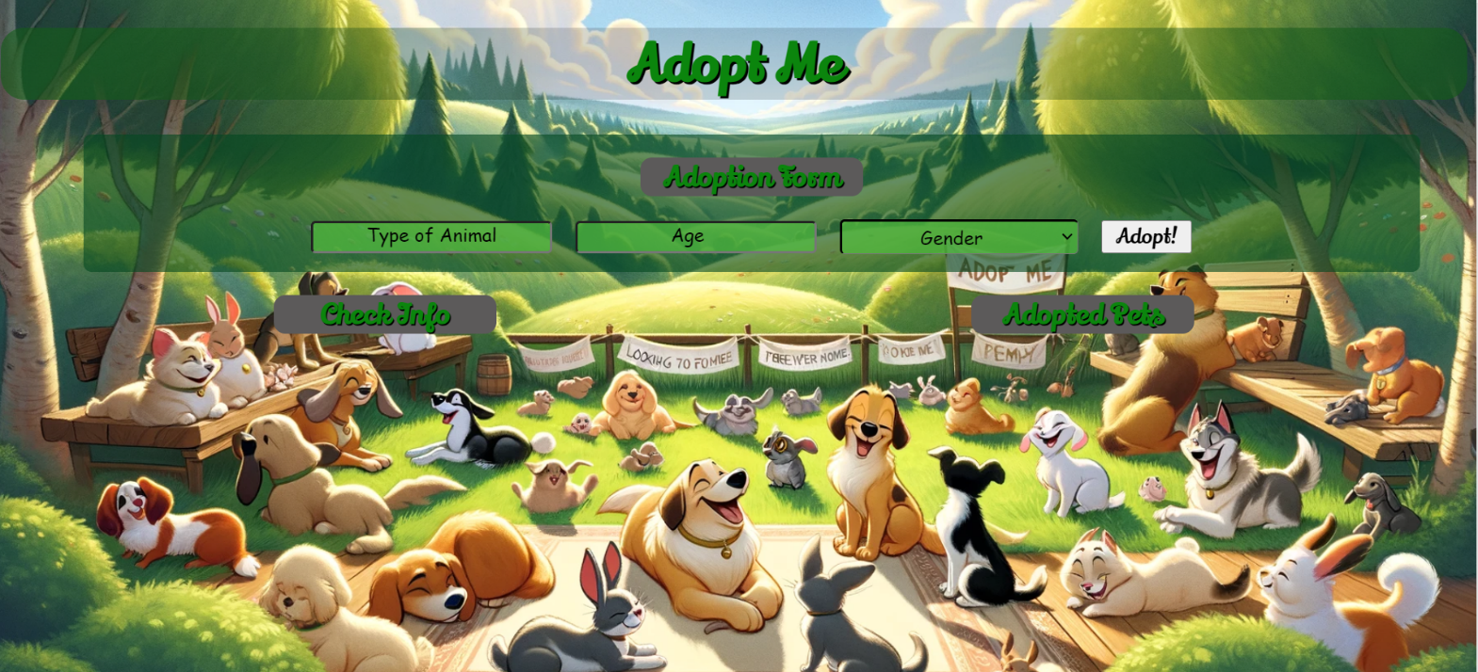

### Your Task

**Write the missing JavaScript code** to make the **Adopt Me** application work as expected:

* + **Type Of Animal, Age,** and **Gender** should be **non**-**empty** **strings**. If any of them are empty, the program should not do anything.

### 1.Getting the information from the form

When you click the **[Adopt!]** button, the information from the input fields must be added to the <ul> with the id "adoption-info"and the input fields should be **cleared**.

The HTML structure should look like this:

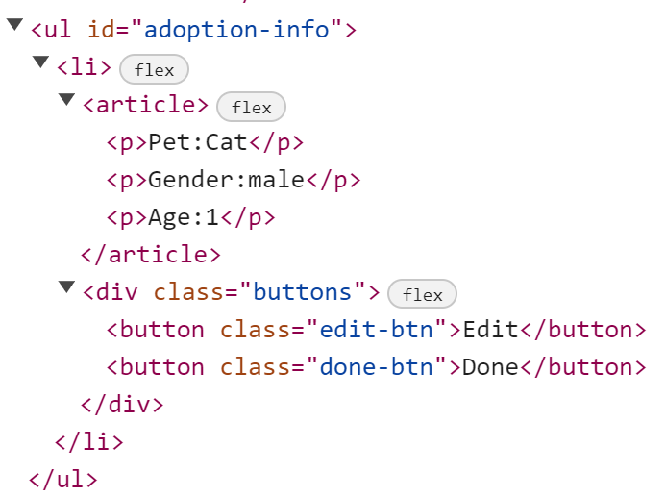

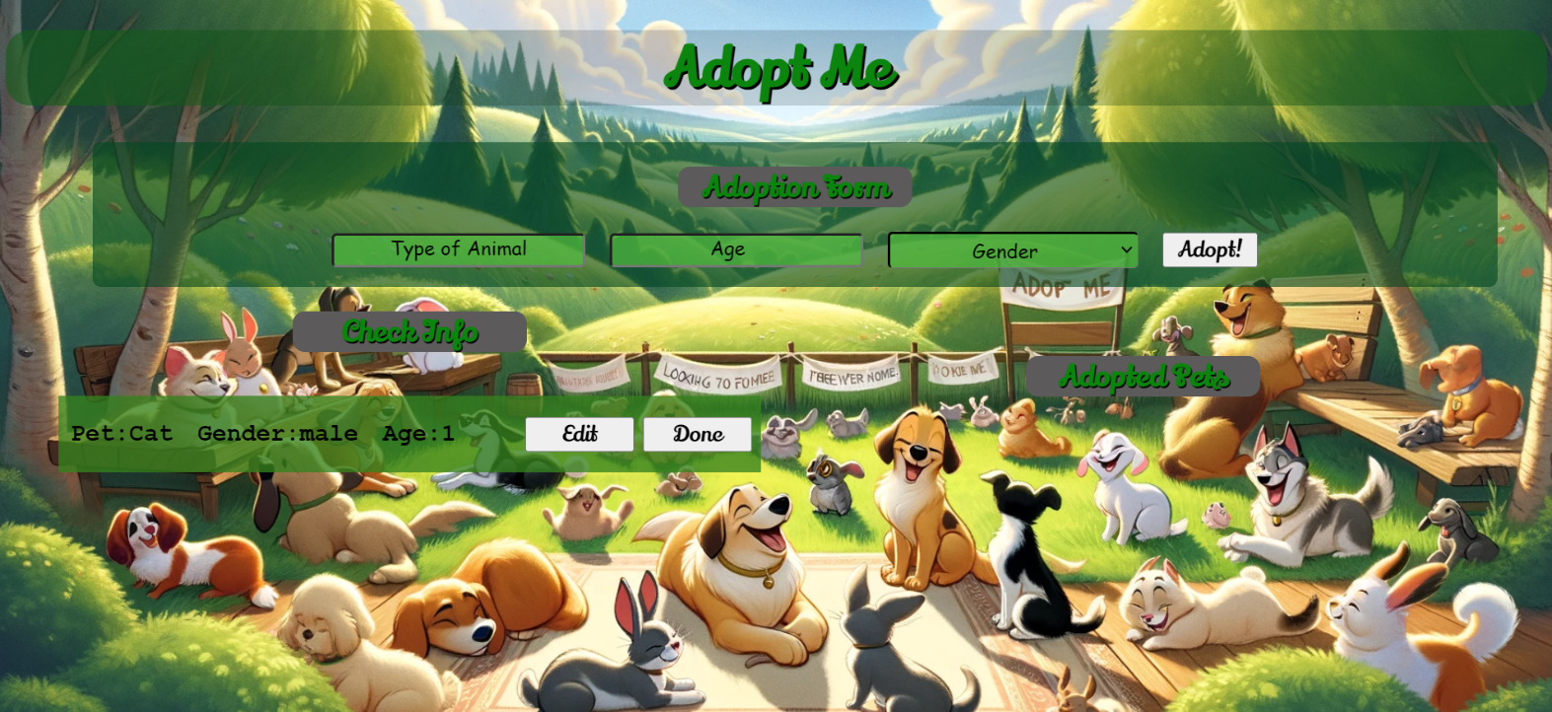

### 2.Edit Info

When the **[Edit]** button is clicked, the information from the check info must be sent to the input fields and the record should be deleted from the <ul> "adoption-info".

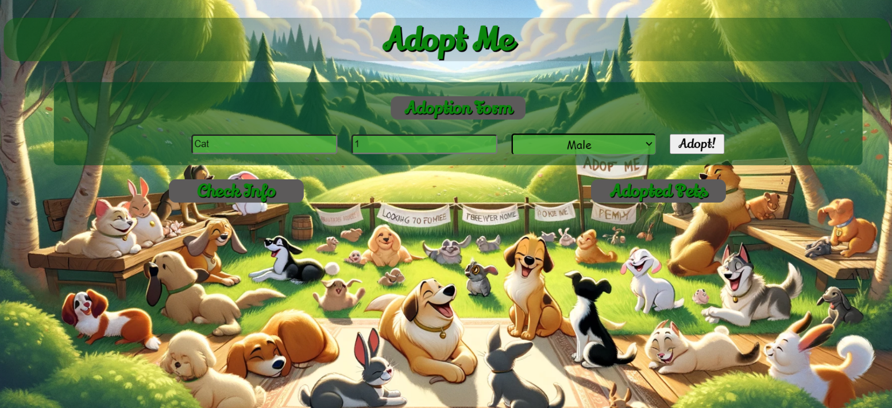

After editing the information, add a new item to the <ul> with the updated information.

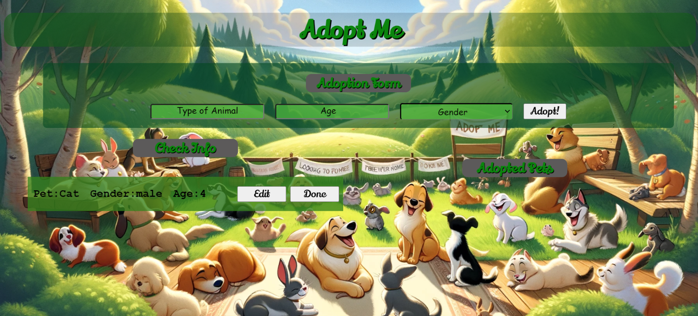

### 3.Finish Adoption

When you click the **[Done]** button, the task must be **deleted** from the <ul>withid"adoption-info" and appended to the <ul> with id "adopted-list".

The **buttons [Edit]** and **[Done]** should be removed from the <li> element and the **button [Clear]** shoud be added.

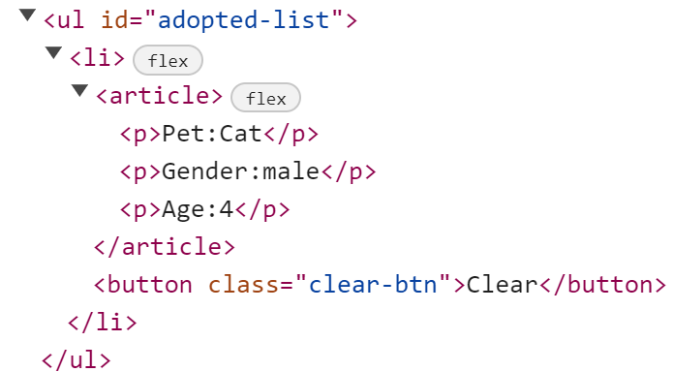 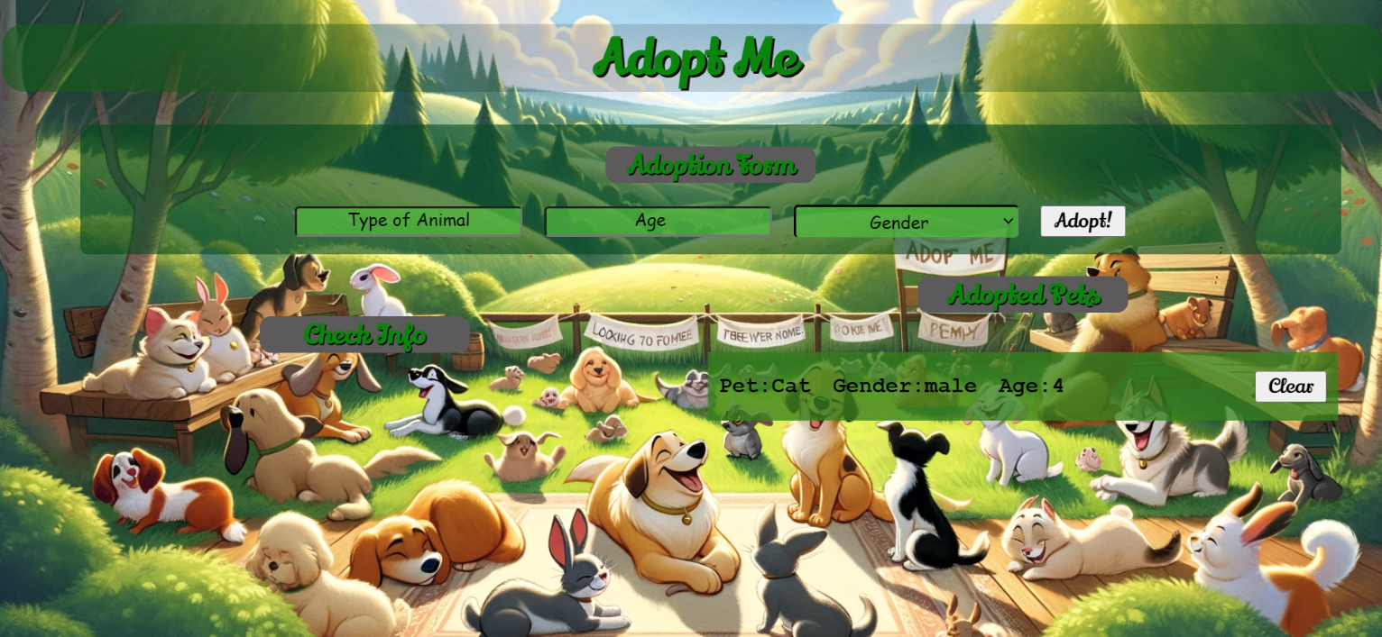

### 4.Clear List

When you click the **[Clear]** button, the task must be **deleted** from the <ul>withid"adopted-list" .

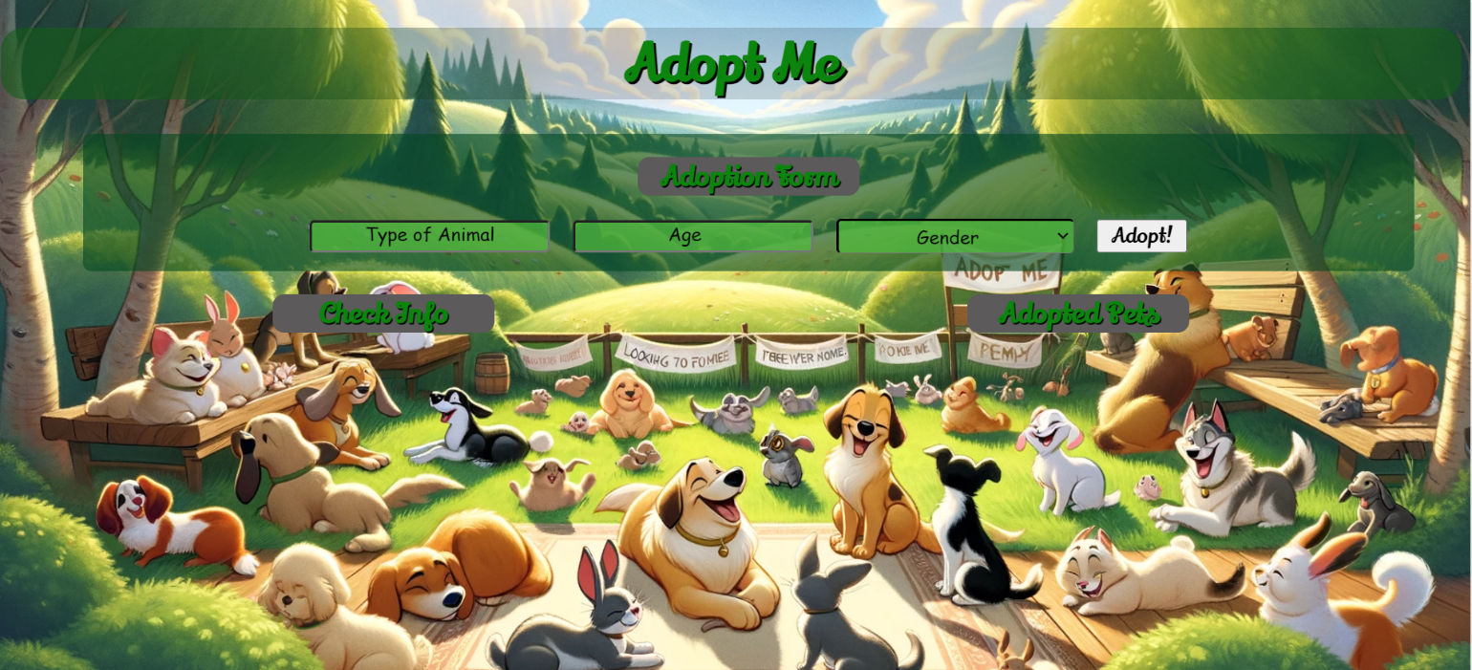

### Submission

Submit only your **solve()** function.

## 3.The Step Challenge

**Working with Remote Data**

For the solution of some of the following tasks, you will need to use an up-to-date version of the **local REST service** provided in the lesson’s resources archive. You can [read the documentation here](https://github.com/softuni-practice-server/softuni-practice-server).

**Environment Specifics**

Please be aware that every JS environment may **behave differently** when executing code. Certain things that work in the browser are not supported in **Node.js**, which is the environment used by **Judge**.

The following actions are **NOT** supported:

* **.forEach()** with **NodeList** (returned by **querySelector()** and **querySelectorAll()**)
* **.forEach()** with **HTMLCollection** (returned by **getElementsByClassName()** and **element.children**)
* using the **spread-operator** (**...**) to convert a **NodeList** into an array
* **append()** (use only **appendChild()**)
* **prepend()**
* **replaceWith()**
* **replaceAll()**
* **closest()**
* **replaceChildren()**

If you want to perform these operations, you may use **Array.from()** to first convert the collection into an array.

### Requirements

Write a JS program that can load, create, remove and edit a list of step records. You will be given an HTML template to which you must bind the needed functionality.

First, you need to install all dependencies using the npm install command

Then, you can start the front-end application with the npm start command

You also must start the ***server.js*** file in the ***server*** folder using the node server.js command in another console **(BOTH THE CLIENT AND THE SERVER MUST RUN AT THE SAME TIME)**.

At any point, you can open up another console and run npm test to test the **current state** of your application. It’s preferable for **all of your tests to pass locally** before you submit to the Judge platform, like this:

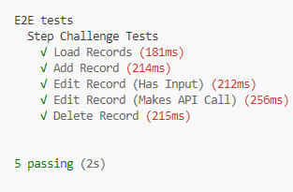

### Endpoints

* <http://localhost:3030/jsonstore/records/>
* <http://localhost:3030/jsonstore/records/>:id

### 1.Load Records

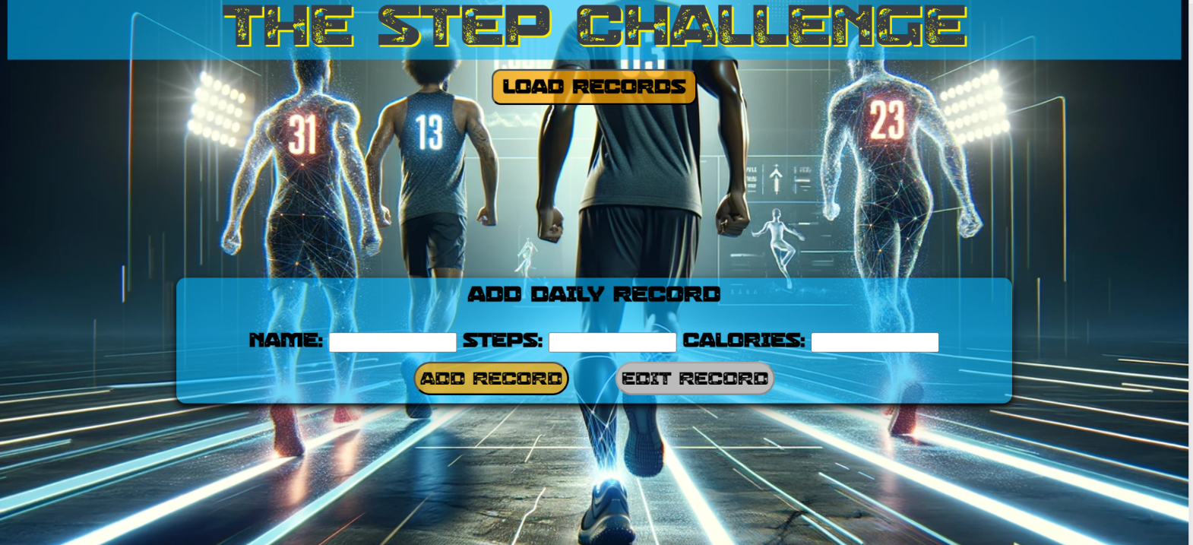

Clicking the **[Load Records]** button should send a **GET** request to the server to fetch **all records** from your local database. You must add each task to the<ul>with **id="list". [Edit Record]** button should be deactivated.

Each record has the following **HTML** **structure**:

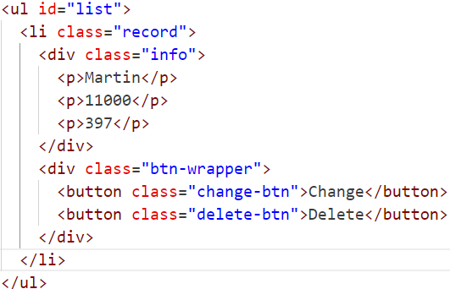

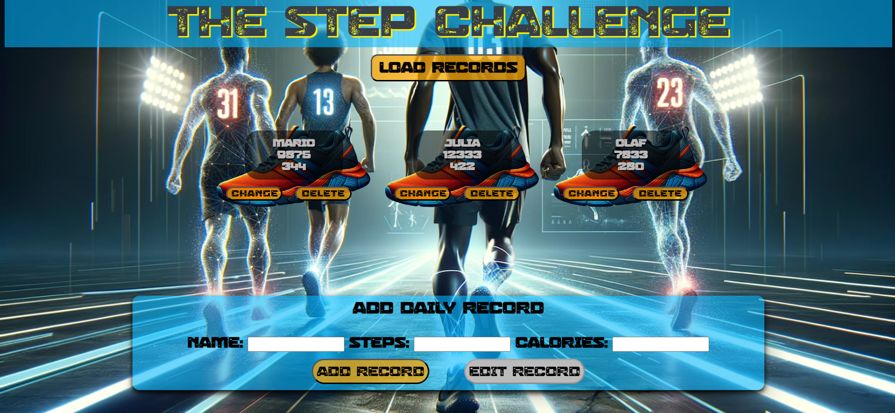

### 2.Add а Record

Clicking the **[Add Record]** button should send a **POST** request to the server, creating a new Record record with the **Name**, **Steps and Calories** from the input values. After a successful creation, you should send another **GET** request to fetch all the records including the **newly added one**. You should also **clear all the input fields** after the creation!

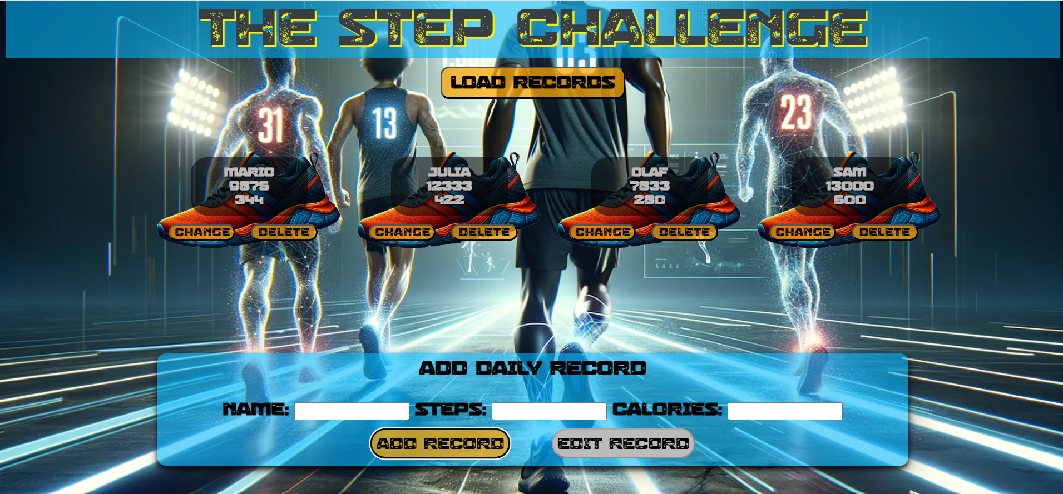

### 3.Edit a Record

Clicking the **[Change]** button should populate the info into the input fields above. The **[Edit** **Record]** button **in the** **form** should be activated and the **[Add Record]** one should be deactivated.

After clicking the [**Edit Record]** button in the form, you should send a **PUT** request to the server to **modify the Name, Steps and the Calories** of the changed item. After the successful request, you should **fetch the items again** and see that the changes have been made. After that, the **[Edit** **Record]** button should be deactivated and the **[Add Record]** one should be activated.



### 4.Delete

Clicking the **[Delete]** button should send a **DELETE** request to the server and remove the item from your local database. After you've removed it successfully, **fetch** the Records **again**.

### Submitting Your Solution

Select the content of your working folder (the given resources). Exclude the *node_modules* & *tests* folders. Archive the rest into a **ZIP** file and upload the archive to Judge.

